SMT2020
Semiconductor Manufacturing Testbed
Data Specification
Release 1.0 - 03/2020

Contents
1. Introduction 2
2. Minimal Structure 2
2.1. options.def 2
2.2. tool.txt 2
2.3. part.txt 4
2.4. route_i.txt 4
2.5. order.txt 4
3. Additional Features 5
3.1. Tools Availability 5
3.1.1. Unscheduled Down Times: Breakdowns 6
3.1.2. Scheduled Down Times: Preventive Maintenance (PM) 7
3.2. Transport Times 8
3.3. Load and Unload 8
3.4. Setups 9
3.5. Batching 10
3.6. Cascading 10
3.7. Lot-to-Lens Dedications 11
3.8. Rework 11
3.9. Sampling of Lots 11
3.10. Dispatching 11
3.11. Hot Lots and Setup Avoidance 12
3.12. Super Hot Lots 12
3.13. Critical Queue Time 12
4. Reports 14
5. Characteristic Features of the Individual Datasets in SMT2020 15

- Introduction
The purpose of this document is to provide the user of the Semiconductor Manufacturing Testbed 2020 (SMT2020) with the technical information necessary to navigate and use the data files. SMT2020 in its final version will include at least two fab models, one High Mix – Low Volume (HM/LV) model, denoted as dataset 1 and a Low Mix- High Volume (LM/HV) model denoted as dataset 2. This document may be subject to changes if improvements in the descriptions of the datasets are required in the future. We therefore ask the readers to pay attention to the version (release number in the title page) they use. We also invite users to contact the authors with any requests or suggestions.
The testbed was created and tested using the AutoSched AP simulation software. The interface for Autosched AP is a set of Excel sheets. Users can either use the model directly in Autosched AP or transfer the data from the Excel data sheets to the simulation tool of their choice. The main features of the two datasets are described in Sections 2 and 3 in an almost dataset-independent manner, whereas the main differences between specific datasets are summarized in Section 4.
An AutoSched AP simulation model is located in the folder model_name.asd. It consists of several files with extension .txt. To create or change a model, the Excel software can be used. The Excel sheets and the corresponding tables will be transformed into the model files (.txt) by exporting the model.
- Minimal Structure
The minimal structure of the models consists of the products, the tools, and the basic data connecting between them (processing time, release rate in the fab, etc.). This minimal structure is fully contained in the five files necessary to run the simulation models in AutoSched AP. These files are described in the following subsections.
  - options.def
This master file is used to control the simulation model. Here, all files and options are listed, for instance, the start date of the simulation, see SIM_START (line 1) in Figure 1. The file names are assigned to the type of the file, e.g. part.txt is a PRODUCT_FILES file (line 12). Furthermore, files can be activated or deactivated, e.g. additional order files to include engineering lots can be used or not. STATION_FILES are the files describing the machines (tools). In our case, the file is called tool.txt (see Section 2.2 for a more detailed description of the file tool.txt).
  - tool.txt

This file describes the machines, called tools, their quantity, and the related rules for lot dispatching. Station families (tool groups) are declared by theirs names in the column STNFAM and the number of tools in the column STNQTY (the default value is one if there is no number defined). All tools of a tool group are assumed to be identical. The name of the first tool (station) is defined in the column STN. Moreover, the tool groups (station families) are grouped in station groups (STNGRP) which can be considered as manufacturing areas. For example, the lithography area consists of eight different tool groups, while each tool group has at least two tools. Station groups can be used, for example, for statistics in the reports. The remaining declarations will be explained when the corresponding additional features are described. The mentioned columns are shown in Figure 2.

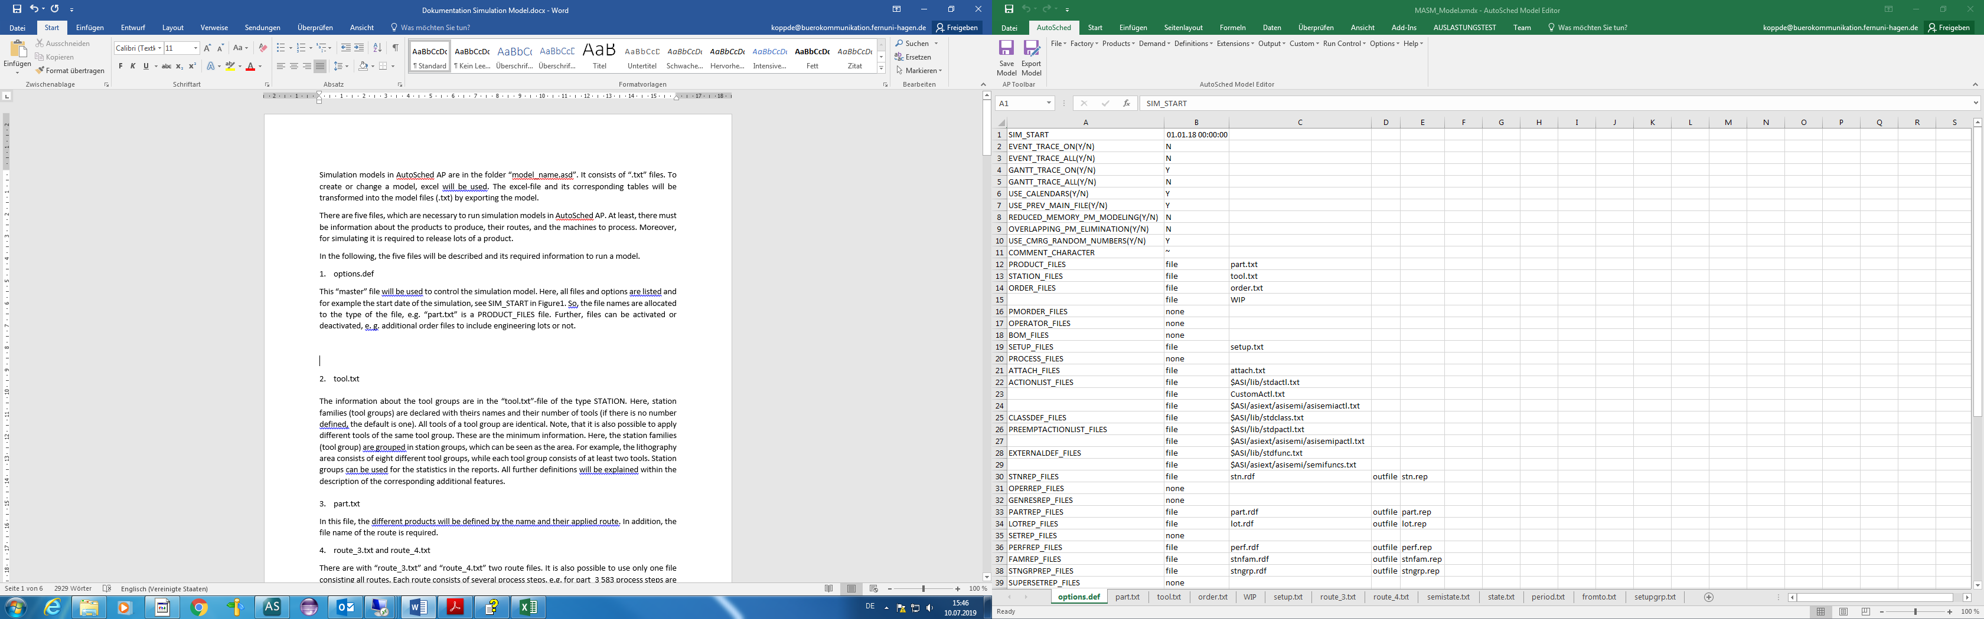
Figure 1 - options.def
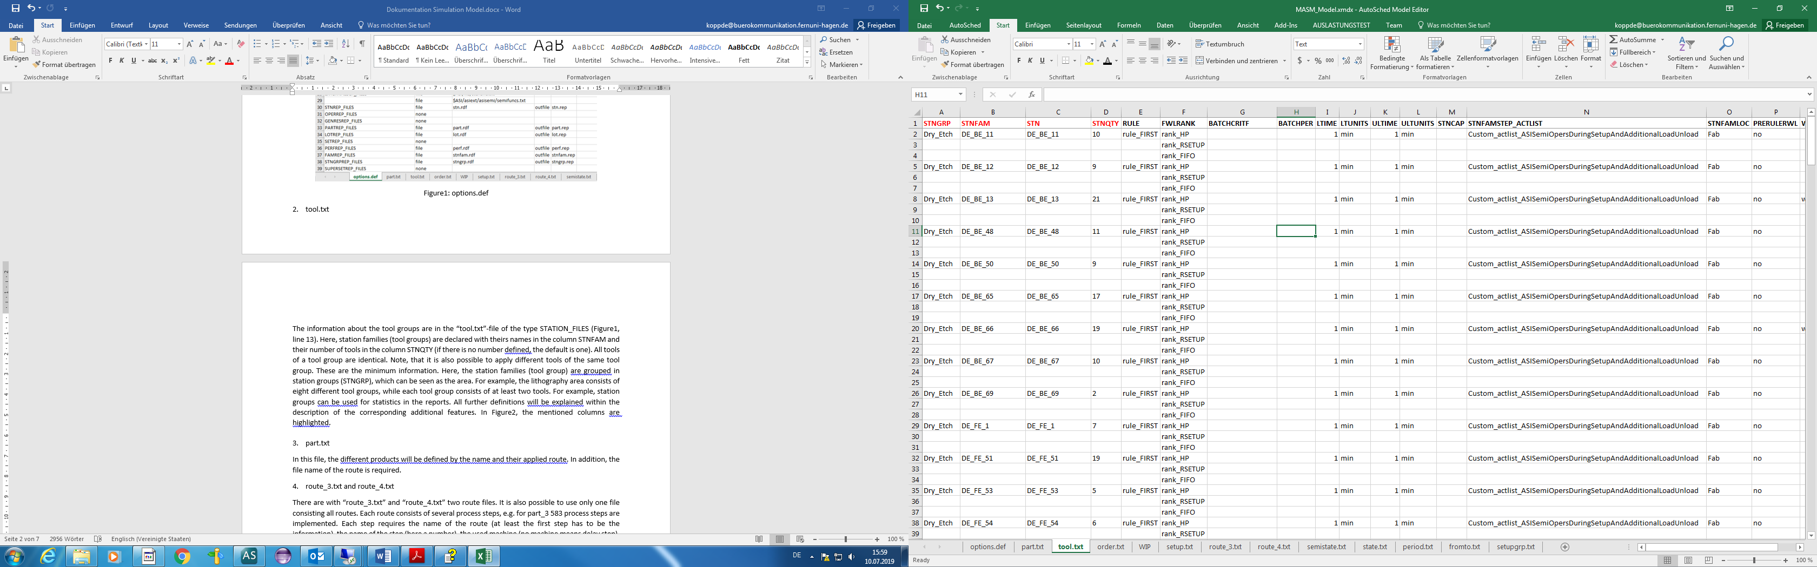
Figure 2 - tool.txt - part I
  - part.txt
In this file (see Figure 3), the different products are declared by name (PART) and their route (ROUTE). The names are used for providing lot release information in the order.txt file, see Figure 5. In addition, the file name of the route is required (ROUTEFILE). The columns PARTGRP and PARTFAM can be used to group related products (PART), e.g. for specific batching criteria. Further, these columns allow for differentiating between product types for reporting purposes.
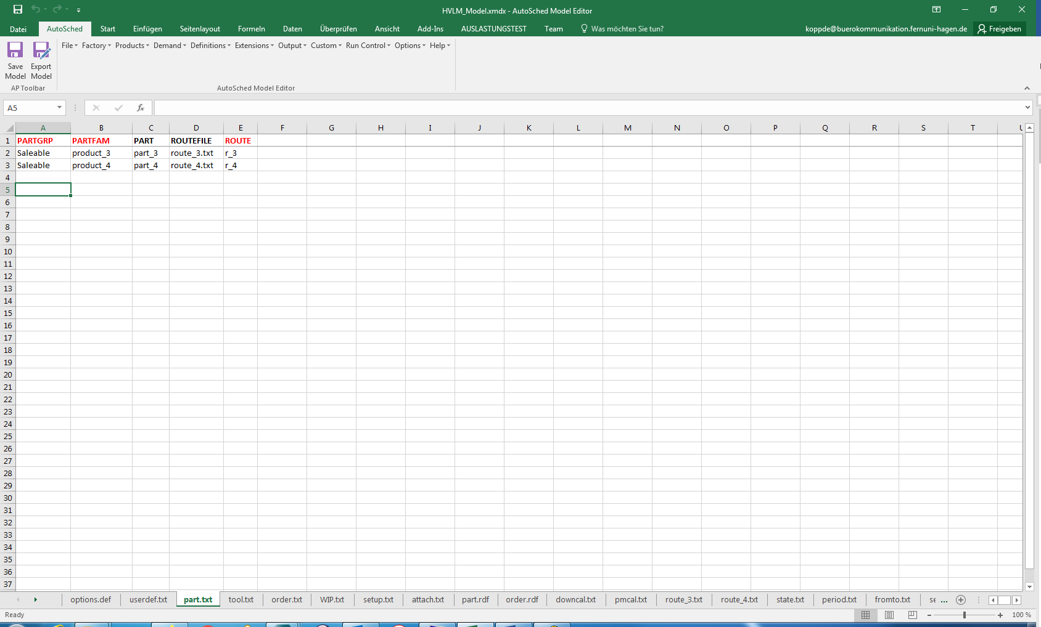
Figure 3 - part.txt
  - route_i.txt
Overall, ten routes (products) are defined in the testbed. All the ten routes are used in dataset 2, while only the products 3 and 4 are included in dataset 1. The details of the required set of process steps are found in the set of files denoted as route_i.txt, i = 1,…,10. It is also possible to use only a single file that contains all routes.
Each route consists of multiple process steps, e.g. 583 process steps exist for part_3. Each step requires the name of the route (ROUTE), the name of the step (STEP; here an integer), the used tool group (STNFAM), and the processing time. The latter will be defined by a probability distribution (PDIST), the amount of time (PTIME and PTIME2), the time units (PUNITS; here in minutes), and the entity type (PTPER) (cf. Figure 4). Hence, the time can be applied for each single wafer (per_piece), for a lot (per_lot), or for a batch (per_batch) in which case the number of wafers in the batch are determined by a minimum and maximum batch size (BATCHMIN and BATCHMAX). Note that a continuous uniform distribution is used (PDIST) which requires two parameters (PTIME, PTIME2). PTIME is the mean, while PTIME2 represents the offset.
Important: The processing sequence is independent from step names (integer values), but it depends on the order from the top to the bottom. The process step is described in the column DESC, here by the original name of the process step. It is provided for the user, but does not affect the simulation. The remaining columns will be explained when the corresponding additional features are described.
  - order.txt
Lots have to be released into the simulation model. Therefore, the name of the lot (LOT), the name of the product (PART), the number of wafers of a lot (PIECES), and the release date (START) are required. To repeat the release of lots after a fixed amount of time, the length of the interval (REPEAT, RUNITS) and the number of replications (RPT#) have to be specified. The number of lots released per interval is defined in the column LOTSPERRPT (the default value is again 1). Furthermore, for each product at least one interval is defined, while a constant distribution is used (RDIST). It is also possible to assign more than one order to a product, for instance for regular lots and hot lots (cf. Figure 5 lines 2 and 4). There are priorities for the different lot types, they are used for lot ranking (PRIOR). A higher priority value indicates a higher importance of a lot. Note that the lot names starting from the second lot will be equipped with the suffix _i, starting with i = 2 in ascending order (for instance, Lot_3, followed by Lot_3_2 and Lot_3_3).
In addition, a due date (DUE) is given. For each lot released during a repeat cycle, a due date will be set based on the current release time and the offset DUE – START. Moreover, orders can be declared (ORDER) by assigning at least one lot to them, multiple lots are possible.
Moreover, lots can be released individually, i.e. without the repeat functionality. For instance, this is used to start with initial WIP (“WIP.txt”). Here the column CURSTEP refers to the current step of the lot.
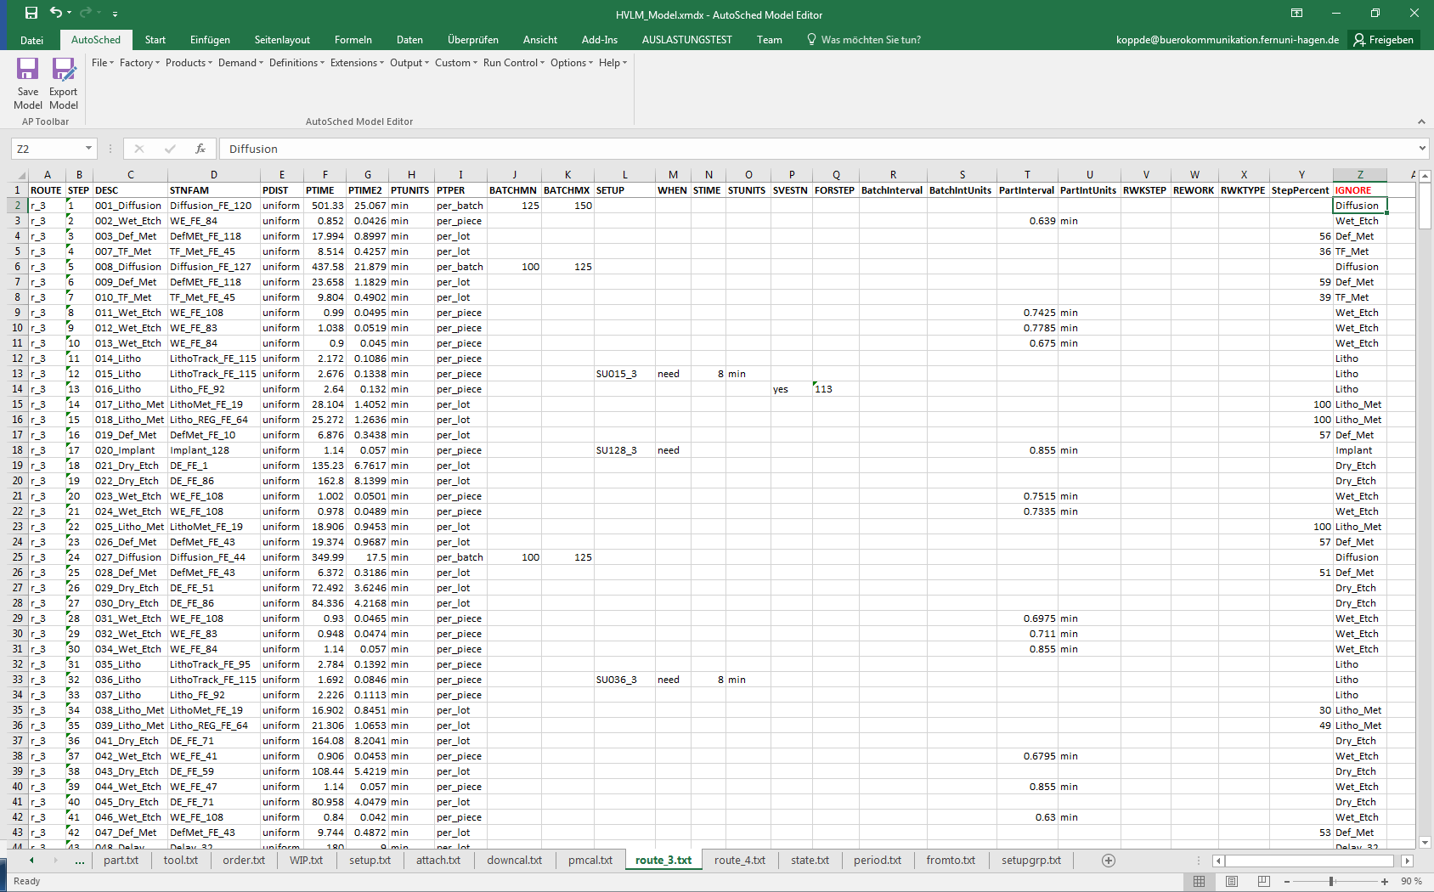
Figure 4 - route_3.txt part I
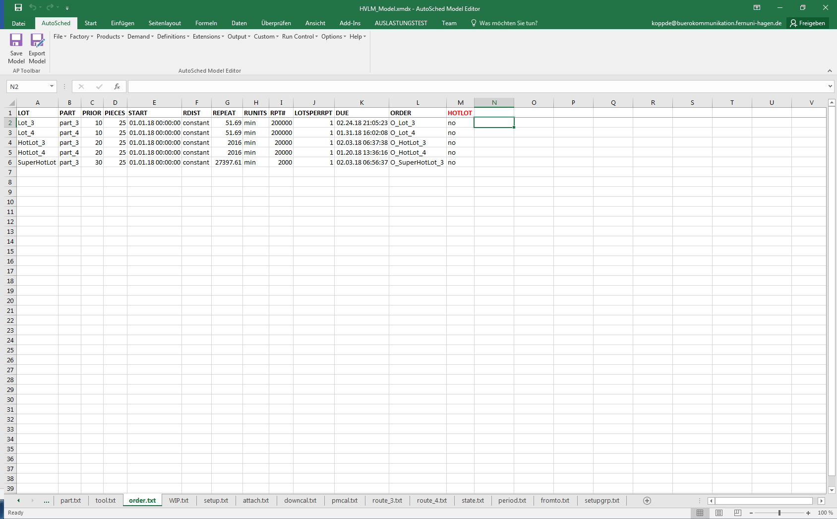
Figure 5 - order.txt
- Additional Features
Used files: options.def, external definition files

The simulation models have several features that will be described next with the related files necessary for their implementation. Activating some of these features requires adding the “semiconductor extension” which is located in the directory of AutoSched AP. It enables further functions, actions or action lists, and rules. There are additional entries in the options file (cf. Figure 1), e.g. ACTIONLIST_FILES in line 24 for the additional action lists and the location of the corresponding file. For more information, the AutoSched AP Help needs to be consulted.
  - Tools Availability
The file attach.txt (see Figure 6) is used to connect each downtime event (unscheduled or scheduled) represented by the name (CALNAME) with the CALTYPE (here down or pm) to a group of tools. The latter is defined by the resource type (RESTYPE) and its name (RESNAME).
Note that CALNAME stands for the name of the downtime event as described in the files downcal.txt and pmcal.txt. For instance, the scenario BREAK_Def_Met specified in the file downcal.txt (cf. Figure 7, line 2) defines a breakdown type valid for all tools of the station group Def_Met (cf. Figure 6, line 2). This station group includes several station families (tool groups) and tools.
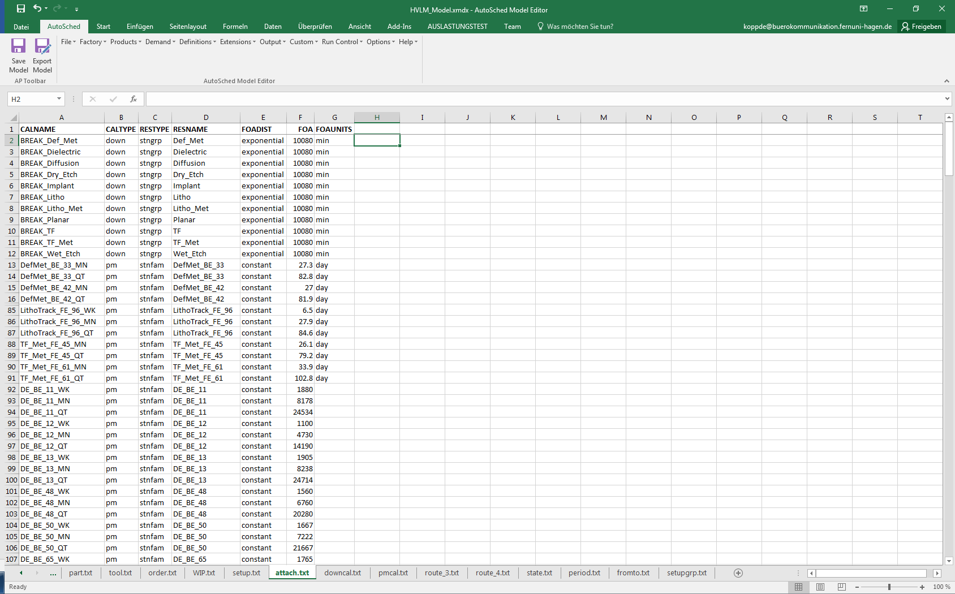
Figure 6 - attach.txt
    - Unscheduled Down Times: Breakdowns
Used files: downcal.txt, attach.txt
Breakdowns are described in downcal.txt, i.e. different down scenarios with their probability distributions of the corresponding Time To Failure (TTF) and Time To Repair (TTR) values are collected (see Figure 7).
For every station group (area) a down scenario is defined which can be identified by its name (DOWNCALNAME). Breakdowns are triggered based on calendars (mttf_by_cal in column DOWNCALTYPE), and the tool usage has no impact on their occurrence. Each breakdown type is characterized by the probability distributions of its TTF and TTR values. The distribution type is given (MTTFDIST and MTTRDIST, here both exponentially distributed). The mean of TTR and TTF (MTTF, MTTR) and their time units are needed (MTTFUNITS and MTTRUNITS, here in minutes).
In addition, in the file “attach.txt” the distribution of the first TTF is defined. In the column FOADIST, the distribution type is stated (here exponentially distributed). The mean of the first TTF (FOA) and the time units are needed (FOAUNITS).
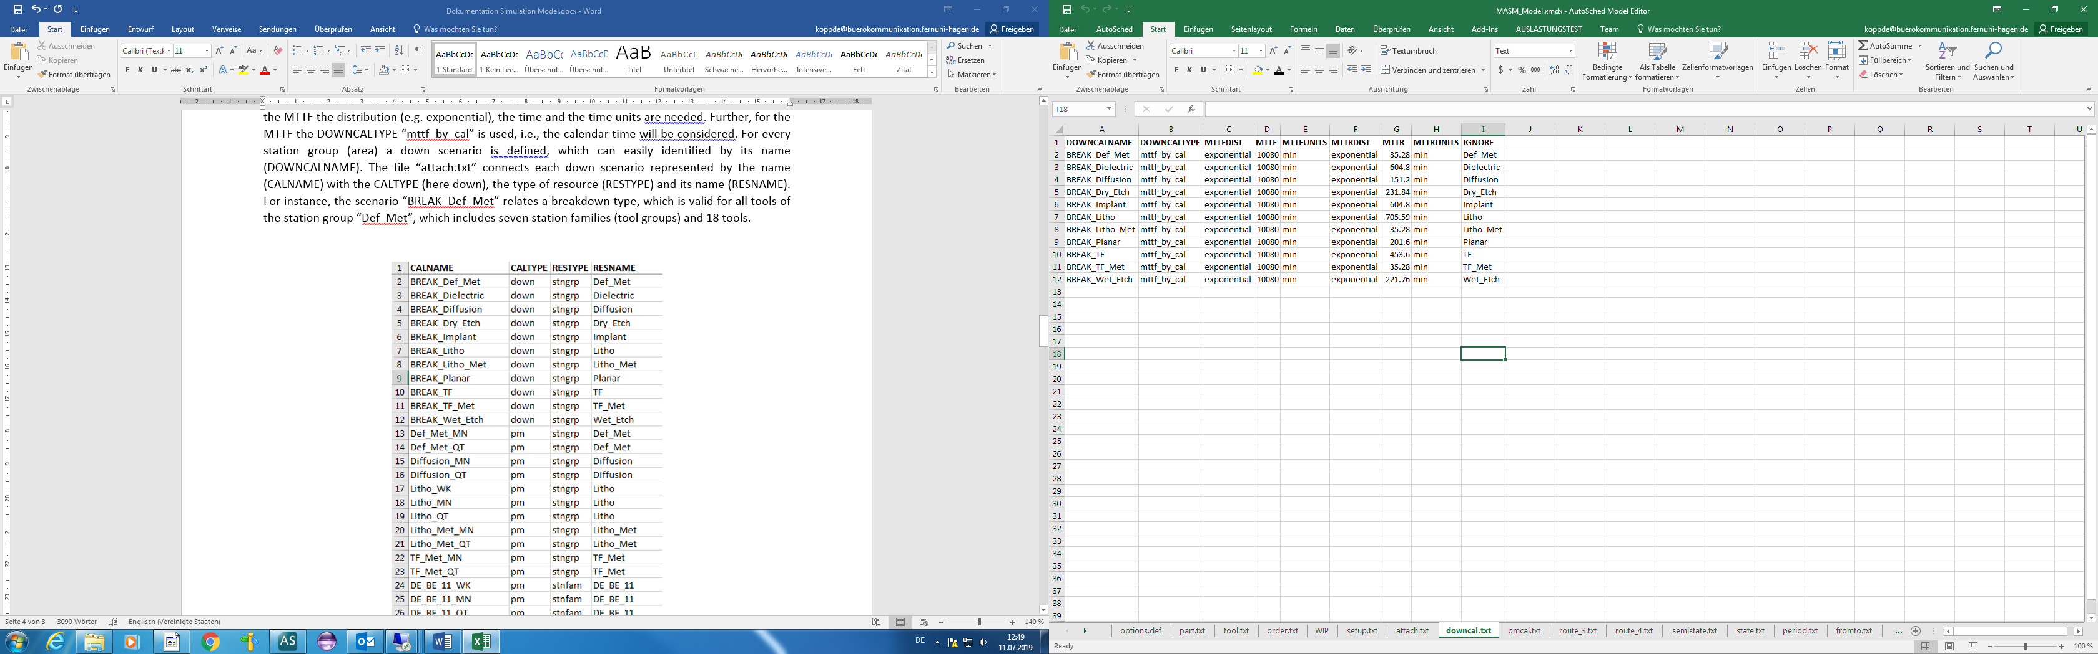
Figure 7 - downcal.txt
    - Scheduled Down Times: Preventive Maintenance (PM)
Used files: pmcal.txt, attach.txt
The representation of PMs works almost in the same way as for breakdowns (cf. Figure 8). Here, two types for the Mean Time Between PM (MTBPM) values are distinguished (PMCALTYPE). The PM is time-based for diffusion, lithography, and metrology represented by mtbm_by_cal to consider the calendar time. For all other tool groups, the PM is counter-based by applying mtbpm_by_pieces, i.e., a PM must be executed after processing a prescribed number of wafers. Hence, the corresponding numbers and units are needed in the columns MTBPM and MTBPMUNITS. Note that no special probability distribution is defined for MTBPM (the default is constant). However, the time-based PMs are practically launched as Mean Time Before PM, so that the PM duration itself is included in the MTBPM value.
A continuous uniform distribution is used to represent the TTR value that requires values for the two parameters MTTR and MTTR2 (mean and offset) and the time unit (MTTRUNITS). For instance, each 30 days a monthly PM and each 91 days a quarterly PM is modeled for the station family DefMet_BE_33 in the lines 2 and 3. In attach.txt file, line 13, a monthly PM is allocated to the station family (RESTYPE = stnfam). Moreover, counter-based PMs are also applied for each station family, i.e., the used RESTYPE is stnfam and the RESNAME is the name of the tool group (see file “attach.txt” or Figure 6, line 92). The prescribed number of wafers is valid for each individual tool of the tool group.
The distribution of the first PM for the tools of a tool group is defined in the column FOADIST (see file “attach.txt”). The constant distribution means that the first PM for the tools of a tool set is evenly distributed based on the value in the column FOA. For example, a FOA value of 80 days with four tools lead to PMs for tool 1, 2, 3, and 4 at the following days: 20, 40, 60, and 80. For counter-based PMs it works in the same way, but FOAUNITS are not necessary.
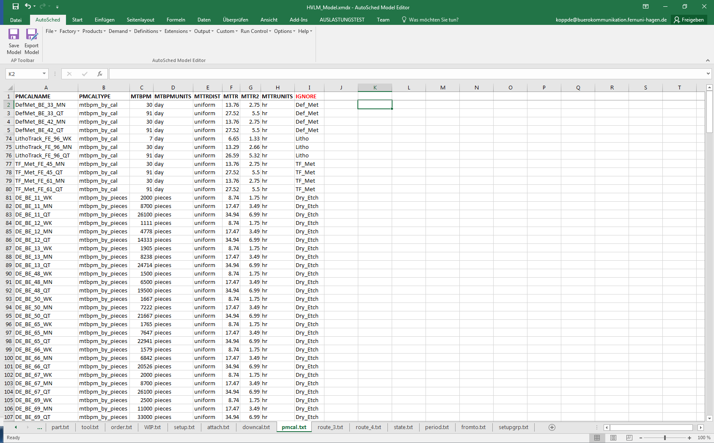
Figure 8 - pmcal.txt
  - Transport Times
Used files: fromto.txt, tool.txt
Transportation is modeled in SMT2020 in the most basic way. All transport times are sampled from the continuous uniform distribution U(5, 10). For this purpose, a location is defined for each tool group in the column STNFAMLOC (see tool.txt or Figure 10). An identical tool group location called Fab is used. The times from a specific location (FROMLOC) to another (TOLOC) have to be specified in the fromto.txt file (see Figure 9). In the datasets, we use only from Fab to Fab as described before. The duration follows a continuous uniform distribution (DDIST) with the given parameter values (DTIME, DTIME2, and DUNITS). There is one exception for the delay steps with respect to the delay tool group since no transport time is applied by defining the location Delay instead of Fab (see tool.txt, line 86).

Figure 9 - fromto.txt
  - Load and Unload
Used files: tool.txt, CustomActl.txt
Loading and unloading is included for each process step (with the exception of delay steps). The load and unload times are the same for all tool groups, their duration is 1 minute each (LTIME, LTUNITS for load and ULTIME, ULUNITS for unload in tool.txt). Note that load and unload times are not included in the processing time. At first, a lot is loaded, processing then occurs, and finally, the lot is unloaded. To implement this behavior, it is necessary to use an appropriate action list (CustomActl.txt, Figure 14). Moreover, this is valid for each process step or each tool. Therefore, it is sufficient to define the used action list for each tool group (see column STNFAMSTEP_ACTLIST in tool.txt shown in Figure 10).
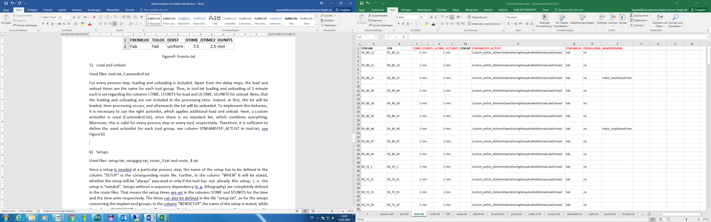
Figure 10 - tool.txt - part II
  - Setups
Used files: setup.txt, setupgrp.txt, route_i.txt files, tool.txt
Since setups are needed for certain process steps, the name of the setup has to be defined in the column SETUP in the corresponding route file (Figure 4). Furthermore, it is stated in the column WHEN whether the setup will be always executed or only if the tool does not have already this setup, i.e., if the setup is needed. Sequence-independent setups, e.g. for lithography, are entirely defined in the route files. This means the setup times are specified in the STIME und STUNITS columns for the setup duration and the time units, respectively. However, the times could also be provided in the setup.txt file, as is done for the setups concerning the implant tool groups, see Figure 11, line 6-14. The name of the setup is stated in the column NEWSETUP while the CURSETUP column is not set. This means that from any current setup to the new setup the defined time is valid. Moreover, there are sequence-dependent setups. For them both the CURSTEP and the NEWSTEP information has to be stated (e.g. see lines 2 and 3 in Figure 11).
In addition, the setup times for changing the gas types are huge for the implant_128, implant_91, and implant_132 tool groups. To avoid frequent setups, the setup avoidance rule rule_LSSU (see tool.txt, line 158) is used which is based on specific setup criteria. They are defined in the file setupgrp.txt (see Figure 12). Here, the gas setups are grouped by the name Implant_Gas (SETUPGRP), the names of the corresponding setups are set in the column SETUP for which the criterion has to be applied. Here, the criterion MINRUN is used, i.e., for a new setup, a minimum number of processed lots is required after a tool has changed its setup. This set is called a run. In addition, the setup group has to be defined for the corresponding tool group in column SETUPGRP in the file tool.txt (e.g. line 158).
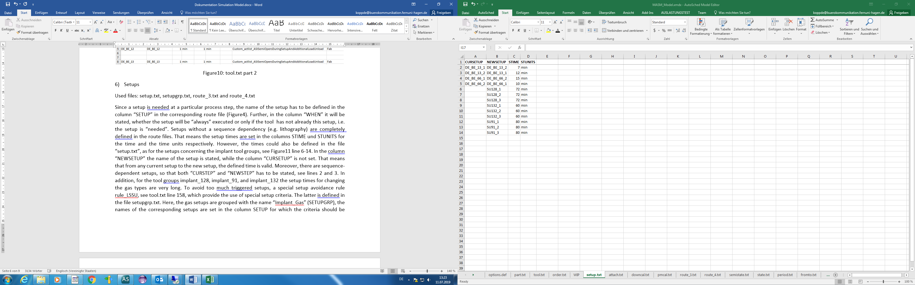
Figure 11 - setup.txt
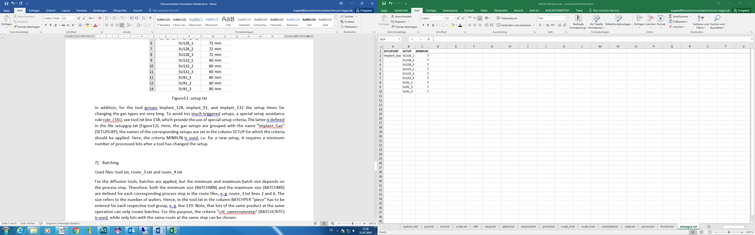
Figure 12 - setupgrp.txt
  - Batching
Used files: tool.txt, route_i.txt files
Diffusion tools are able to process several lots at the same time on the same tool. We refer to the resulting group of jobs as a batch. Both the minimum possible batch size (BATCHMN) and the maximum possible batch size (BATCHMX) are defined at the relevant steps in the route files, e.g. in route_3.txt, lines 2 and 6 (see Figure 4). The sizes are given in number of wafers. Hence, in the column BATCHPER of tool.txt file piece has to be entered for each batch processing tool group, e.g. in line 119. Note that only lots of the same product at the same process step can be used to form a batch. For this purpose, the crit_sameroutestep batch criterion (BATCHCRITF) is used.
It is also possible to allow batches with production lots belonging to a particular product and engineering lots from a specific engineering product derived from the former product. First, the same PARTFAM, e.g. “product_3”, has to be defined for the production product and the corresponding engineering product (see Figure 3). Moreover, two batch criteria crit_samepartfam and crit_samestepname has to be used, so that only lots with the same name of PARTFAM and at the same process step, i.e. the same name of the step, can be used to build a batch.
  - Cascading
Used files: options.def, tool.txt, route_i.txt files
Cascading is a characteristic of some stations that are composed of a series of modules able to process materials simultaneously. Wafers/lots need to be processed by several modules one after the other, but while an earlier lot/wafer is undergoing a later phase in the process, the following lot/wafer can be undergoing an earlier phase in the process. As a result, the time required for the first wafer (or lot) to exit the machine is different (longer) than the time between successive lots.
In order to model this, the semiconductor extension is applied. It is necessary to distinguish between cascading lots or wafers, i.e. whether the processing on a tool is per wafer or per lot. In any case, a station capacity (STNCAP) of 2 has to be stated in the tool.txt file, see lines 89 and 95 for each corresponding tool group. If there is no entry, e.g. line 92, no cascading is implemented since the default is 1. The processing times of the process steps are set in the route_i.txt file as described before, a non-cascading tool only takes into account the columns PDIST, PTIME, PTIME2, PTUNITS, and PTPER. The specified time is valid for each lot or wafer (PTPER). Hence, the time between two finished lots or wafers on a tool is at least this stated time. For a cascading tool (STNCAP = 2), the same time is valid for lots and wafers, but in contrast, during the processing of the first lot or wafer, the processing of the second begins in parallel, since the capacity is 2. Therefore, the time between finished lots depends on the time defined in the BatchInterval and BatchIntUnits columns. The processing of the second lot can start after the time interval. This is also true for lots on different operations with different processing times since a cascading machine (capacity of 2) can be seen as a tool with two successively slots. After the cascading time interval (BatchInterval), the first lot goes from slot 1 to slot 2. At the same time, the processing of the second lot begins (slot 1). After the time interval of the second lot, it can again go from slot 1 to slot 2, if the first lot is finished (slot 2 is free). As soon as slot 1 is free, the next lot can be started.
Cascading of wafers is modeled in an analogous way, while the PartInterval and PartIntUnits columns are used (e.g. see Figure 4, line 3). There is an option to add a setup delay to the interval time. The SEQ_ADDS_SETUP_DELAYS flag takes the value N in the options.def file if there is no setup, while the default value is Y. Hence in the former case, the interval time includes only the processing part, defined in the mentioned columns, setup times are not included in addition. Sequential processing of lots are applied for the tools in the planar, thin films, and half of the tools in dielectric areas. Cascading takes place for wafers in the wet etch and implant areas.
  - Lot-to-Lens Dedications
Used files: route_i.txt files

In some critical Litho layers, wafers are required to return to the same specific tool for a series of consecutive layers to reduce the yield loss due to overlay issues. We refer to this issue as Lot-to-lens dedication. To ensure that exactly the same tool is used for process step i and process step j (i < j), the name of process step j has to be entered in the FORSTEP column at operation i and “yes” has to be included in the SVESTN column (see route_3.txt or Figure 4, line 14). This behavior can be extended for process step k etc. (i < j < k) by including the corresponding information of step k at step j in the same way as described before (see route_3.txt, line 14 and 114).

  - Rework
Used files: route_i.txt files

Implementing rework requires the use of the RWKSTEP, REWORK, and RWKTYPE columns in the route files. REWORK refers to the probability that a lot needs rework and is presented as a percentage of the overall number of lots sent to rework. As an example, in route 3, 1.7% of the lots are reworked, i.e., a lot has a probability of 0.017 of being sent to rework. It is defined in the RWTYPE column whether the rework is applied to the entire lot or to a single wafer (in the provided datasets, only entire lots are reworked). The lot will be sent to the process step stated in the RWSTEP column. For instance, the lot is sent from process step 67 to step 65 of the route_3.txt file when rework occurs.

  - Sampling of Lots
Used files: route_i.txt files

Not all lots are inspected at metrology operations, but rather some lots are sampled to monitor the health of the preceding process. It is possible to simulate sampling by using the semiconductor extension, i.e. to process only a random sample of lots at a specific operation. In the StepPercent column, the probability that a lot will be processed is given (see route_3.txt or Figure 4, line 4).

  - Dispatching
Used files: tool.txt, order.txt
In both models, a baseline rule is used to prioritize between lots queueing in front of any tool group. The First-Come First-Served (FCFS) dispatching rule is applied in dataset 1 representing a fab owned by a semiconductor company that produces to stock. For dataset 2 representing a foundry, i.e. it produces to order a large variety of products, the Critical Ratio (CR) dispatching rule is applied. Local rules and special lots that break the baseline rule are described in the following subsections.

  - Hot Lots and Setup Avoidance
Here, the rule_FIRST rule (RULE) and multiple ranking functions (FWLRANK) are used. They are defined for each tool group. At first, highest priority lots are preferred, i.e. hot lots before regular lots (rank_HP). This is stated in the PRIOR column in the order.txt file (Figure 5). Ranking is then carried out based on the least setup time (rank_RSETUP) and finally the FIFO (rank_FIFO) criteria. If there is one hot lot chosen, it can trigger a setup. If there are two or more hot lots (same priority), they will be ranked by least setup time and then by FIFO (dataset 1). The critical ratio (CR) dispatching rule is applied in dataset 2. The rule_FIRST rule means that the first ranked lot is chosen. A specific setup criterion, namely rule_LSSU, is applied at the implant tool groups. Lots are processed as described above, but a minimum number of lots is ensured in a run (Figure 12). The behavior described so far refers to the situation that a tool chooses the next lot out of all waiting lots in front of the tool group. In addition, if a lot arrives at a tool group with more than one idle tool, applying the wake_LeastSetupTime criterion in the WAKERESRANK column in tool.txt ensures that the tool that causes the least setup time is used. This is defined for all tool groups with setups.

  - Super Hot Lots
Used files: tool.txt, order.txt, route_i.txt files
Using the semiconductor extension, it is possible to include Super Hot Lots which can reserve a tool at the next process step. First of all, Super Hot Lots have the highest priority (i.e. 30, see the order.txt file). To enable the reservation function, the lot has to be set as a “HOTLOT” and the rule_HotLotFirst rule (column RULE in tool.txt) has to be applied. It can be set in the order file if a lot is a HOTLOT or not (Figure 5). If there is a yes for the Super Hot Lots, they reserve a tool at the next downstream step. The tool only waits until the Super Hot Lot arrives. A setup will be performed if necessary. The setup is carried out as soon as the Super Hot Lot is at the tool and not before. The rule_HotLotFirst rule is a combination of Hot Lot first and rule_SemiFirst second. The latter is very similar to rule_FIRST. This rule for Super Hot Lots is not used for the implant tool groups with the special setup criterion since a specific rule for considering the setup criterion is applied (rule_LSSU). The duration of the reservation can be adjusted in the route_i.txt files using the HOTLOTDELAY% column. Here, the column is not explicitly used since the default is 0.

  - Critical Queue Time
Used files: userdef.txt, route_i.txt files
There is no extension for critical queue times provided by AutoSched AP. Therefore, customizing is necessary to take into account critical queue times, i.e. custom functions e.g. for a dispatching strategy. However, here only the corresponding data is provided for all routes and it is prepared for customization.

The critical queue times refer to a set of consecutive process steps. Therefore, the data is stated in the route files, see Figure 13. First, the new columns STEP_CQT, CQT, and CQTUNITS has to be defined, see the file “userdef.txt”, Figure 14. The FIELDNAME is the custom name for the field, while these fields can be added in the file stated in the column FILETYPE, here route file. The required type of data for the fields is set in the DATATYPE column. TYPESTRING refers to text, TYPEREAL to real numbers, and TIMEUNITS to time units (seconds, minutes, etc.). Further, these are no default fields by creating new route files (DEFAULTFIELD) and the data is not protected as read-only (PROTECT). In addition, a description is set for all new fields (DESCRIPTION).

The critical queue time is defined by the amount of time (CQT) and the time units (CQTUNITS; here in hours). The time between the end of processing on a certain step and the begin of processing on a specific step must not exceed the critical queue time. For example, the critical queue time (CQT) has to be considered after processing on step 413 (STEP) until the begin of the processing on step 414 (STEP_CQT), see Figure 13 lines 414 and 415. That means, on the step, where the critical queue time starts (STEP), the information is given about the critical queue time (CQT, CQTUNITS) and the step, where the constraint ends (STEP_CQT).
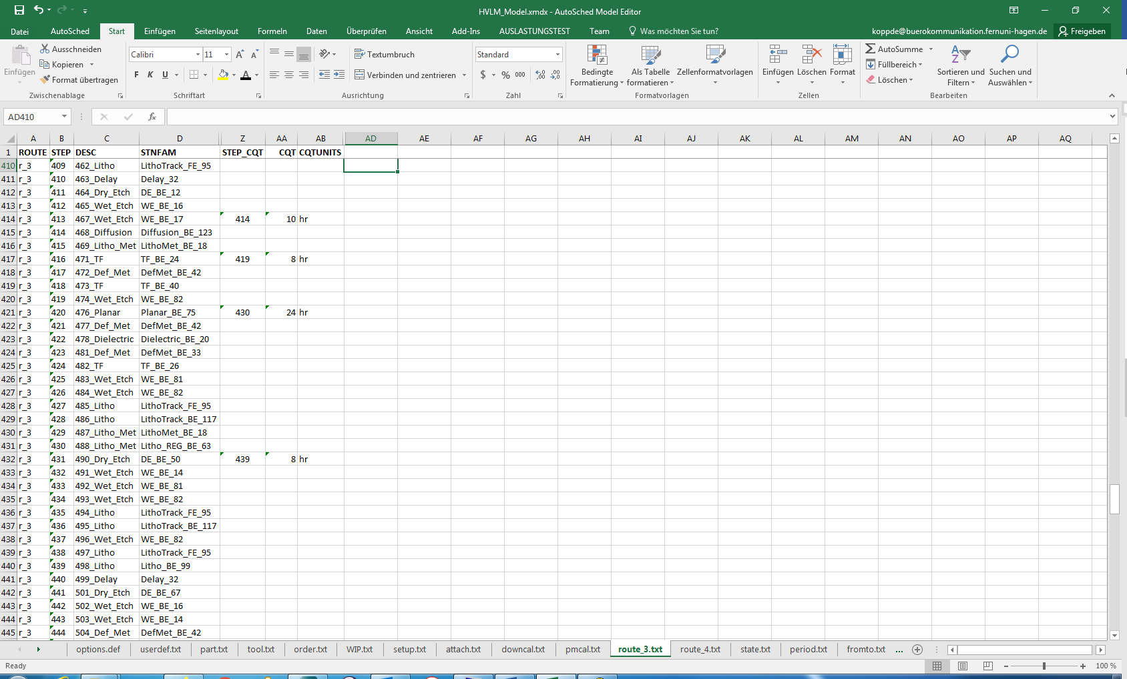
Figure 13 – route_3.txt part II

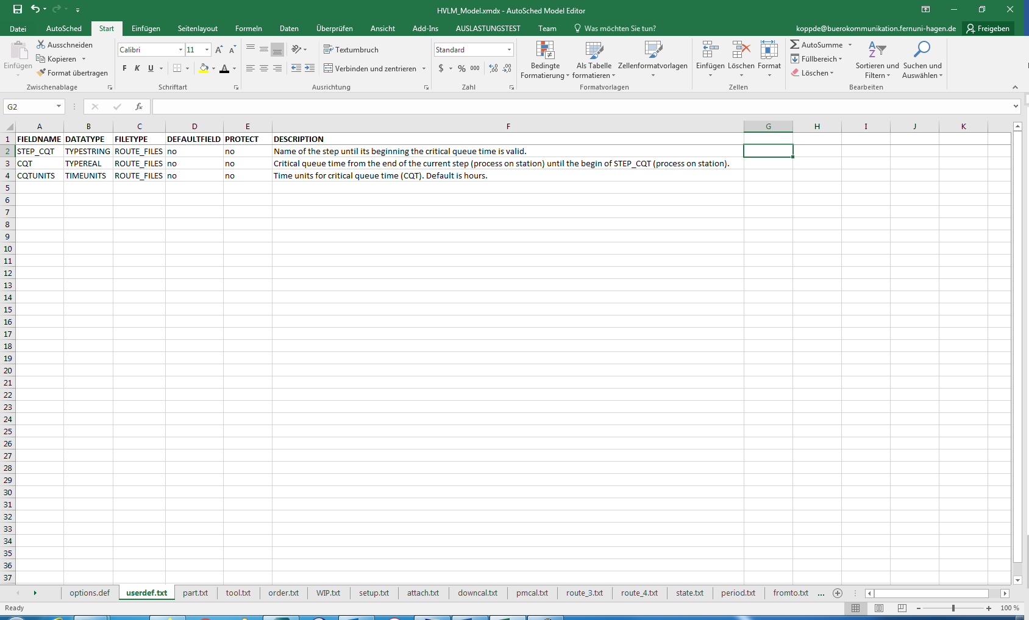
Figure 14 – userdef.txt

- Reports
Used files: *.rdf files, state.txt, CustomActl.txt, period.txt

For those users that choose to run the models in AutoSched AP, some basic instructions to navigate the report options are provided.

There are report files (with file extension .rdf) for different entities (part, lot, station etc.). It is possible to extend a report by using additional columns, while a description of each value will be provided. Load and unload are introduced as new states (see the state.txt file in Figure 13). Both states are no unavailable states (UNAVAILSTATE), they belong to the utilization for the statistic (UTILSTATE), and a percentage statistic is also provided (PERCENTSTATE).

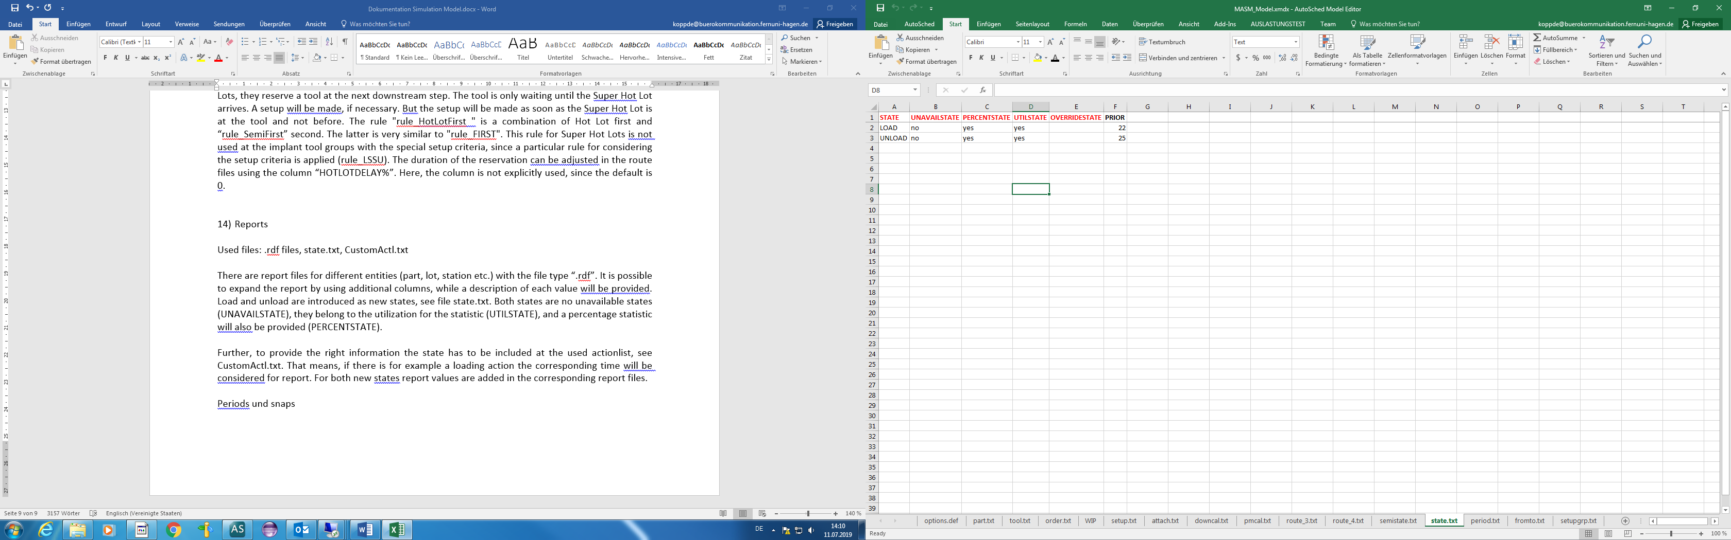

Figure 13 - state.txt
A state has to be included at the used action list to provide the appropriate information (see CustomActl.txt, Figure 14). That means if there is, for instance, a loading action the corresponding time is considered for the report. Report values are added for both new states in the corresponding report files.

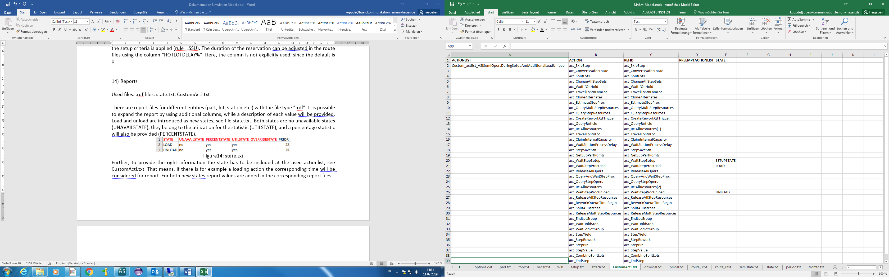

Figure 14 - CustomActl.txt
Moreover, the statistics can be separately reported for time periods like years. Four periods are defined with their name (PERIOD), start date (PERIODSTART), and information on whether the statistics will be reported or not (REPORT) in the file period.txt (Figure 15). The RESET column provides the option to delete previous statistics. Here, the first year represents the warm-up phase, while the statistics are reported. However, these numbers are not included in the statistics of the following years since it is a reset.

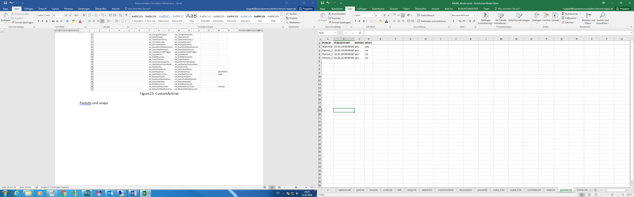

Figure 15 - period.txt
- Characteristic Features of the Individual Datasets in SMT2020
The main differences between the two datasets and important similarities are summarized in Table 1. A file WIP.txt represents an ORDER_FILE (see Figure 1). It contains initial WIP arising from a simulation run at high utilization.
Table 1 - Datasets specifics
Feature | dataset 1 (HV/LM) | dataset 2 (LV/HM)
#products | 2 (route_3.txt, route_4.txt) | 10 (route_1.txt – route_10.txt)
initial WIP | for 2 products, dataset-specific WIP.txt | for 10 products, dataset-specific WIP.txt
#tools | dataset-specific tool.txt | dataset-specific tool.txt
counter-based PM | dataset-specific pmcal.txt | dataset-specific pmcal.txt
due date setting | (optional) dataset-specific order.txt | (mandatory) dataset-specific order.txt, multiple due date scenarios
dispatching rules | FIFO, treatment of hot lots and setup avoidance is unified in both datasets | CR, treatment of hot lots and setup avoidance is unified in both datasets

